**PRE PLE -2020**

**P.7 INTEGRATED SCIENCE SET 3**

*Time allowed: 2 Hours 15 minutes*

Candidate’s Name: ...................................................................................

Index No.

School: ...................................................................................................................

***SECTION A***

1. Name the sense organ which tells that tea is very sweet.

________________________________________________

2. What problem results after the eardrum has burst in the ear?

________________________________________________

3. Why is forest conservation encouraged in Uganda?

________________________________________________

4. How is a plate stand useful to a family in a home?

_____________________________________________

5. Identify the type of joint in the body which gives a wide range of movement.

________________________________________________

6. Give one advantage of Bio-gas production to environment?

________________________________________________

7. What does the experiment below show?

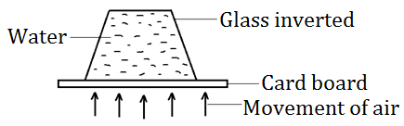

________________________________________________ ________________________________________________

8. How is a short circuit dangerous in a home?

________________________________________________

9. State one effect of polio disease to an individual.

________________________________________________

10. Why is friction said to be a nuisance force?

________________________________________________

11. How do animals make use of the gas given out by plants during respiration?

________________________________________________

12. Identify the simple machine shown below.

_____________________________________

13. State any one similarity between a rat and a bat as a mammal.

________________________________________________

14. Which blood cells are destroyed by a plasmodium germ?

________________________________________________

15. How do humans get infected with tape worm?

________________________________________________

16. Complete the diagram showing light rays as they leave the lens below.

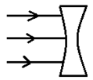

17. What problem is Jenifer likely to face if she eats food without washing her hands?

________________________________________________

18. Why is rubber and plastics used to insulate electric live wires?

_____________________________________________

19. Name one object which floats on water.

________________________________________________

20. Which type of teeth is used for cutting food?

________________________________________________

21. Which part of the human ear is responsible for balancing the body?

________________________________________________

22. How can the volume of irregular objects be measured?

________________________________________________

23. Give one danger of digging in wetlands.

________________________________________________

24. Why is sandy soil not good for farming?

________________________________________________

25. Identify one common secondary characteristic in both boys and girls.

________________________________________________

26. How is a dustbin useful in a school?

________________________________________________

27. Give one method of making a temporary magnet.

_______________________________________________

28. How is wind used as an energy resource?

________________________________________________

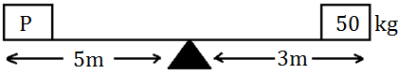

29. Find the weight of ‘P’ if the level is balancing.

30. Why is tying between the heart and injured part a good first aid for a snake bite?

________________________________________________

________________________________________________

31. Which vector is responsible for spreading sleeping sickness in homes?

________________________________________________

32. A block has a mass of 24gm and a density of 4gm/cc. Find its volume.

33. Which immunisable disease makes the muscles of a person stiff?

________________________________________________

34. On the diagram below, show the position of the pivot with letter P.

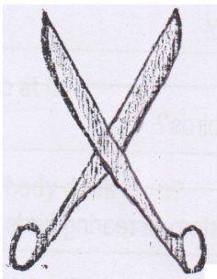

35. Give the use of saliva in the digestion process.

______________________________________________

36. How is the human skin a useful organ of the body?

______________________________________________

37. Mention one health habit which keeps kidneys healthy.

______________________________________________

38. State one use of light from the sun in the environment.

______________________________________________

39. Give one disadvantage of the range system of rearing animals.

________________________________________________

40. How is a Vent Pipe on a VIP Latrine Useful?

________________________________________________

***SECTION B: 60 Marks***

41. (a) Name any one example of poultry.

________________________________________________

(b) Why do farmers keep Dual purpose birds?

________________________________________________

(c) Give one disadvantage of battery system of rearing birds.

________________________________________________

(d) Identify a poultry disease caused by protozoa.

________________________________________________

42. (a) What is dehydration?

________________________________________________

________________________________________________

(b) Give one sign of dehydration.

________________________________________________

(c) Mention one cause of dehydration.

________________________________________________

(d) How can dehydration be controlled?

________________________________________________

43. ***The diagram shows a human kidney***.

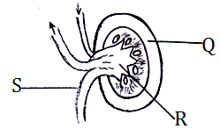

(a) Name the part labeled R.

________________________________________________

(b) What activity is done at Q?

________________________________________________

(c) To which part of the body does S go?

________________________________________________

(d) Give one disease which affects the kidneys.

________________________________________________

44. ***The diagram shows a baby who received immunization***.

Show the immunizable sites for (i) DPT Vaccine ii) Measles Vaccine

iii) BCG iv) Polio Vaccine

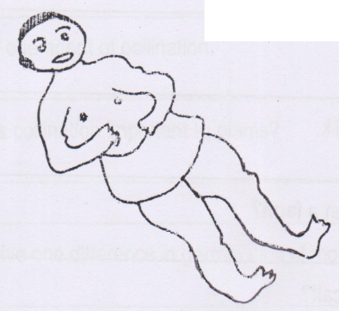

45. (a) What are organic manures?

________________________________________________

________________________________________________

(b) Name two types of organic manures.

(i) ______________________________________________

(ii) ______________________________________________

46. (a) Give any two ways how animals depend on plants.

(i) ______________________________________________

(ii) ______________________________________________

(b) Identify one way how plants depend on other plants.

________________________________________________

(c) Mention one way how animals depend on other animals.

________________________________________________

47. (a) How is sound energy produced?

________________________________________________

________________________________________________

(b) Why do we store sound?

________________________________________________ (c) Give one factor determining the pitch of sound.

________________________________________________

________________________________________________

(d) Name one percussion instrument.

________________________________________________

48. (a) State one way of preserving milk.

________________________________________________

(b) Why is inbreeding a bad practice on a farm?

________________________________________________

(c) How is colostrums milk good to a calf?

________________________________________________

(d) Name one viral disease in cattle.

________________________________________________

49. ***The diagram below shows a human eye. Use it to answer questions about it***.

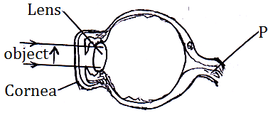

(a) Name the part labeled with letter P.

________________________________________________

(b) Draw the image of the object in the eye.

________________________________________________

(c) State the use of the cornea.

________________________________________________

(d) Name any one eye defect.

________________________________________________

50. (a) Identify two types of pollination.

(i) ______________________________

(ii) ______________________________

(b) Give one agent of pollination.

________________________________________________

(c) How is pollination important to plants?

________________________________________________

51. (a) Give one difference in germination of monocotyledonous and dicotyledonous.

( b) Mention one condition required for a seed to germinate.

________________________________________________

(c) Apart from using chemicals, give two ways of controlling pests in a garden.

(i) ______________________________________________

(ii) ______________________________________________

52. (a) Identify two uses of carbondioxide in daily life.

(i) ______________________________________________

(ii) _____________________________________________

(b) Other than carbon dioxide, name any other gas that form part of air.

______________________________________________

(c) State one disadvantage of wind in the environment.

________________________________________________ ________________________________________________

53. ***The diagram shows a freely suspended magnet A. Magnet B was brought close to it as shown in the diagram***.

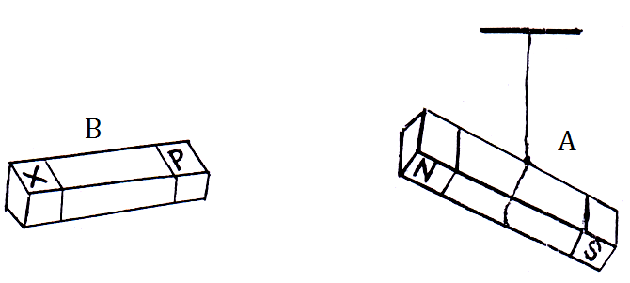

(a) Name pole P of magnet B.

________________________________________________

(b) Why did magnet A and B remain apart as shown?

________________________________________________

________________________________________________

(c) Give one way of demagnetizing magnets.

________________________________________________

(d) How are magnets useful in the environment?

________________________________________________

54. (a) Name the blood vessel which carries deoxygenated blood from the body back to the heart.

________________________________________________

(b) What type of blood is carried by the Aorta?

________________________________________________

(c) State one function of blood in the body.

________________________________________________

________________________________________________

(d) How is the HIV/AIDS virus a danger to the circulatory system?

________________________________________________

________________________________________________

55. (a) Give any two requirements for starting a farm.

(i) ______________________________________________

(ii) ______________________________________________

(b) Why are income and expenditure records kept on a farm?

(i) _____________________________________________

(ii) _____________________________________________

***END***